Recommended Specifications for
Stravigym GympactLayer

Section 13 48 00 Sound Control
This document is for specification writers' reference in the drafting process. CDM Stravitec will not be held responsible for the use or unauthorized modification of any information contained herein.
Specification notes are identified in the document as follows “SPEC NOTE” – these notes must be removed from final documents. Where multiple options may be available, these are identified in the corresponding spec note.

Text highlighted in yellow indicates text that should be coordinated with the entire spec book or represents sections that are options not found on every installation.

This document specification has been specifically written for the Stravigym GympactLayer system. Below is a schematic indication of the construction process from start to end as described in this specification.

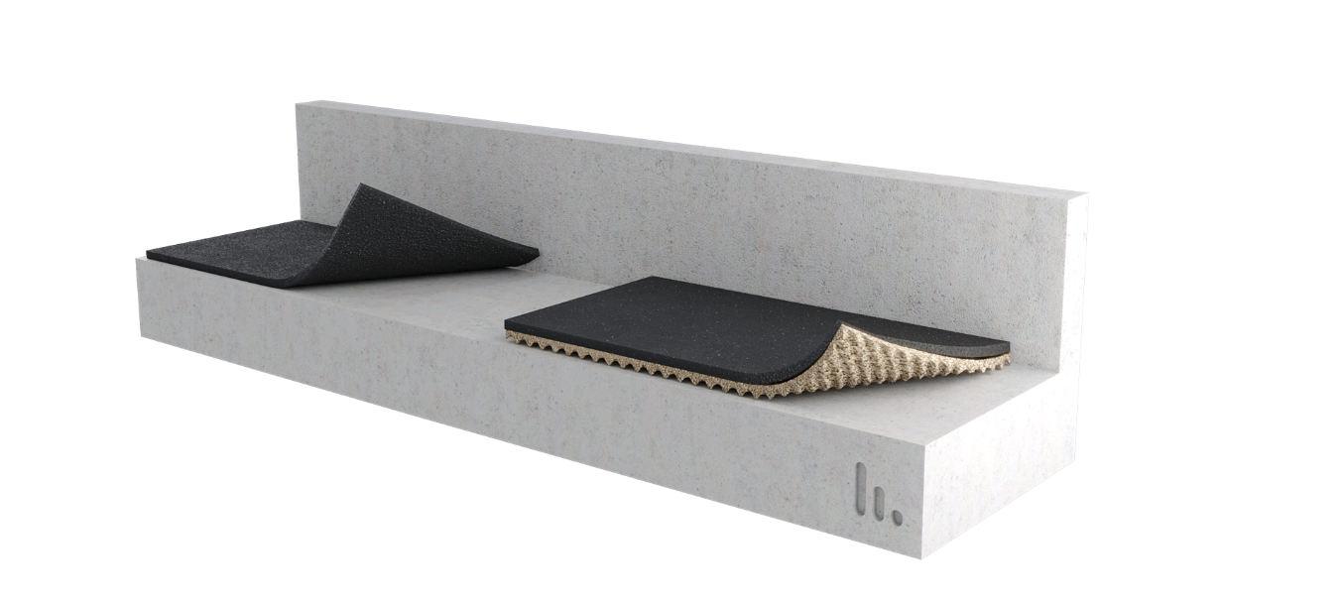

PART 1 GENERAL
  - SUMMARY

- Furnish and install all materials, labor, tools, appliances, and equipment and perform all operations necessary for installation of the isolated floating floor system, Stravigym GympactLayer, as shown on the contract drawings and/or as described in the contract documents.

  - Related SECTIONS

Shall include but not be limited to:
- Subflooring: Section 061623

SPEC NOTE:
1) Stravigym GympactLayer solution require a flat and level floor to be specified. (Note to Specifier: FF 25 as minimum – meaning a single ¼’’ (6 mm) defect across 10-feet (3 m)).

  - SYSTEM DESCRIPTION
The isolated floating floor system shall be designed, supplied, and installed as detailed in the contract drawings, and include the following components:
SPEC NOTE:
Choose one of the following options as desired by the design team.

- Stravigym GympactLayer-45:
  - Top Layer: 13/16’’ (20 mm) flat roll of resilient impact absorption layer made of agglomerated recycled SBR (Styrene Butadiene Rubber) with a PU (Polyurethane) elastomer bonding agent, with an apparent density of 44 lbs/cu-ft (710 kg/m³) and a creep rate (at 44 psi (0.3 MPa)) < 1,5% free height/decade minute according to ISO 8013.
  - Backing Later: 1’’ (25 mm) dimple roll of resilient impact absorption layer made of agglomerated recycled SBR (Styrene Butadiene Rubber) with a PU (Polyurethane) elastomer bonding agent.
Mat capable of achieving a resonant frequency as low as 17Hz, with deflection not bigger than 15% of initial thickness.
Mats must have a creep rate < 1.5% (dec./min.) at maximum static load.

[OR]

- Stravigym GympactLayer-20: 13/16’’ (20 mm) flat roll of resilient impact absorption layer made of agglomerated recycled SBR (Styrene Butadiene Rubber) with a PU (Polyurethane) elastomer bonding agent, with an apparent density of 44 lbs/cu-ft (710 kg/m³) and a creep rate (at 44 psi (0.3 MPa)) < 1,5% free height/decade minute according to ISO 8013.

SPEC NOTE:
OPTIONAL ITEM: Stravigym GympactFloor – above impact absorption layers if required by acoustic consultant or design team and compatible with the layers bellow.

- Stravigym GympactFloor: Check related Guide Specs

  - SUBMITTALS
- LEED: Provide documentation of how the requirements for credit will be met.
1. List of proposed materials with recycled content. Indicate pre-consumer and post-consumer content.
2. Product data and certification letter indicating percentage of recycled content for both pre-consumer and post-consumer content.
3. Recycled content is defined in accordance with the International Organization for Standardization document, ISO 14021 Environmental labels and declarations.
a. Post-consumer material - waste materials diverted from the waste stream after consumer or commercial use.
b. Pre-consumer material - materials diverted from the waste stream during the manufacturing process. Excluded are regrind, rework, and scrap.
- Solution Data: Submit solution data, including manufacturer’s guide specifications product sheet, for specified products.
- Shop Drawings: Manufacturer’s specifications, catalog cuts, and other items needed to demonstrate compliance with the specified requirements. Also, the manufacturer’s recommended installation procedures, which, when approved by the architect, will become the basis for accepting or rejecting actual installation procedures used in the work.
- Samples: Submit selection and verification samples for thickness and shape.
- Installation Manual: Manufacturer’s installation instructions.

  - QUALITY ASSURANCE

- The Stravigym GympactLayer system shall be installed by an experienced installer specialized in the installation of similar work to that of this project, either under direction from or by authorization of CDM Stravitec.
- The Stravigym GympactLayer manufacturer shall have a minimum of 10 similar projects within the past 5 years and be capable of providing field service representation during installation.
- The system shall be designed and fabricated by CDM Stravitec and subjected to CDM Stravitec Quality Assurance program.

  - DELIVERY, STORAGE, AND HANDLING

- Ordering: Comply with the manufacturer's ordering process and lead time requirements to avoid project delays.
- Delivery: Deliver materials in manufacturer's original, unopened, undamaged containers with identification labels intact.
- Storage and Protection: Materials shall be stored in a conditioned space recommended by the manufacturer and protected from external weather conditions.

  - PROJECT CONDITIONS

    - If site conditions are unsatisfactory or raise questions about the installation and/or performance of the floating floor, the work shall not proceed until the condition has been corrected in a manner acceptable to meet the Isolated Floating Floor System Manufacturer’s guidelines.

  - WARRANTY

- Manufacturer’s Warranty: Submit, for the owner’s acceptance, the manufacturer’s standard warranty document executed by an authorized company official. The manufacturer’s warranty is in addition to and not a limitation of other rights the Owner may have under Contract Documents.

PART 2 PRODUCTS
2.01 MATERIALS
- Manufacturer:
CDM Stravitec, Inc.
Address: 342 N. Queen St., Warehouse D, Lancaster, PA 17603
Phone: 888-454-6236
Email: info-us@cdm-stravitec.com
Web: www.cdm-stravitec.com

- Products:
  - Stravigym GympactLayer and associated accessories as described in Part 1 of this Section.

2.02 SUBSTITUTION OF MATERIALS

OPTIONAL ITEM: Choose one of the following statements as desired by the design team.

- Substitute materials shall meet or exceed the “quality and performance” of the products which are listed in these Specifications. Submit samples and test reports by an independent laboratory for consideration on this project.

[OR]

- No substitutions are permitted.

PART 3 EXECUTION
3.01 INSTALLATION

- The installation of the Isolated Floating Floor System specified herein shall be in accordance with procedures submitted by the System manufacturer and approved by the Design Team (architect, structural and acoustical).
- Stravigym GympactLayer rolls shall be flat, smooth structural surface, cleared of debris and broom swept; any required waterproofing properly installed. The flatness of the supporting floor should be a maximum of 1/4” (6 mm) over 10’ (3 m) – F_{F} 25 (according to ASTM E1155-14 and American concrete Institute publication ACI 302) - to ensure a successful installation.
If the supporting floor is not completely flat and level then use a fast-drying, self-levelling compound across the whole floor to achieve required flatness criteria.
- The mat(s) should be unpacked and unrolled (dimple-side down of backing layer), stored it in the room where the installation will take place and allowed to acclimate to its environment for 24 hours or more before installation, maintaining a constant room temperature between 65°F - 95°F (18°C - 35°C).

SPEC NOTE:
Choose D and E of the following statements if Stravigym GympactLayer-45 and F if Stravigym GympactLayer-20.

- Backing layer mat must be installed side by side onto the subfloor with the wavy side directing to the subfloor, removing all trapped air and cut to the desired length. Proceed the installation covering the entire floor. After completion, mat should cover the entire flooring area without gaps. Never glue or fasten this mat mechanically to the subfloor.
- Top layer should be installed on top, criss-crossed, so the top layer joints are not located in the same place as the layer joints underneath.
- It must be installed side by side onto the subfloor, removing all trapped air and cut to the desired length. Proceed with the installation covering the entire floor. After completion, the mat should cover the entire flooring area without gaps.

SPEC NOTE:
OPTIONAL ITEM: Stravigym GympactFloor to be specified by acoustic consultant or design team.
- The final floor finish (by CDM Stravitec – Stravigym GympactFloor (-P)), should be installed using the manufacturers installation instructions, following them installation instructions. Ensure that the final floor finish is not rigidly connected to the surrounding walls.
- All sound isolation materials and building components supported by isolation materials are to be completely free from rigid contact with any part of the building structure.

  - PROTECTION

    - Foot traffic during installation shall be kept to a minimum.
    - Products shall be protected from damage during construction.
    - Any vented or open perimeters shall remain free and clear of debris.
    - The operation of heavy equipment and machinery on the floating floor shall be verified with the manufacturer before use.

END OF SECTION

