Recommended Specifications for
Stravigym SP

Section 13 48 00 Sound Control
This document is for specification writers' reference in the drafting process. CDM Stravitec will not be held responsible for the use or unauthorized modification of any information contained herein.
Specification notes are identified in the document as follows “SPEC NOTE” – these notes must be removed from final documents. Where multiple options may be available, these are identified in the corresponding spec note.

Text highlighted in yellow indicates text that should be coordinated with the entire spec book or represents sections that are options not found on every installation.

This document specification has been specifically written for the Stravigym SP system. Below is a schematic indication of the construction process from start to end as described in this specification.

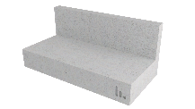 | 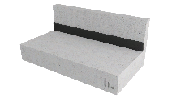 | 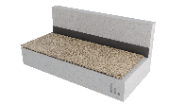 | 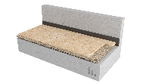 | 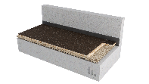 | 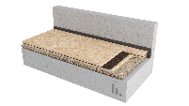
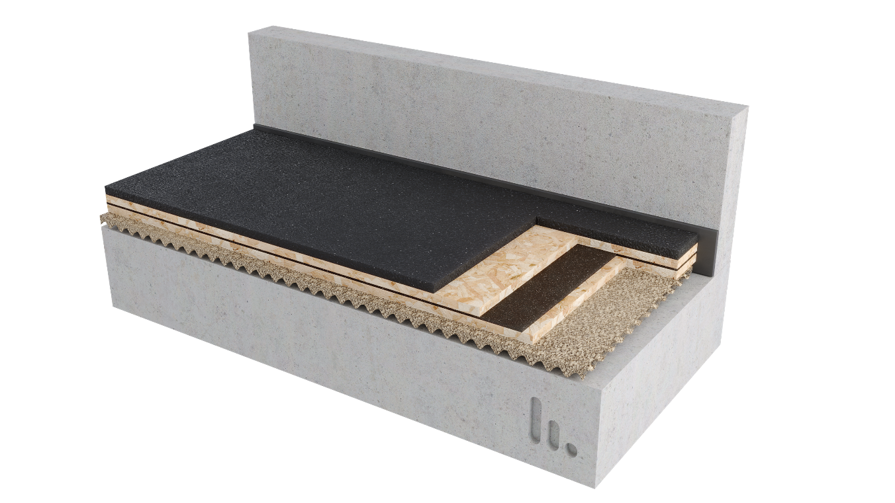

PART 1 GENERAL
  - SUMMARY

- Furnish and install all materials, labor, tools, appliances, and equipment and perform all operations necessary for installation of the isolated floating floor system, Stravigym SP, using floated panelized subfloor composites, as shown on the contract drawings and/or as described in the contract documents.

  - Related SECTION
Shall include but not be limited to:
- Subflooring: Section 061623

SPEC NOTE:
- Stravigym SP systems require a clean, flat and level structural floor to be specified. (Note to Specifier: FF 25 as minimum – meaning a single ¼’’ (6 mm) defect across 10-feet (3 m)).
- Caulking: This is to be coordinated with the appropriate specification or specified herein. Care should be taken to identify the proper acoustical caulking if it is in a separate specification section.

- Caulking: Section 079200

  - SYSTEM DESCRIPTION
The isolated floating floor system shall be designed, supplied, and installed as detailed in the contract drawings, and include the following components:
- Resilient support: CDM Stravitec Roll-W25, 1’’ (25 mm) wavy mat made of regenerated rubber with a high-performance and resilient bonding agent, capable of achieving a resonant frequency as low as 17 Hz with deflection not bigger than 15% of initial thickness.
Mats must have a creep rate < 1.5% (dec./min.) at maximum static load.
- Panels: 4 ply plywood boards or structural OSB boards with a minimum thickness of 19/32’’ (15 mm) and recommended thickness of 23/32” (19 mm).

SPEC NOTE:
Floor covering manufacturer representative and/or installing contractor should be consulted prior to construction of isolated floor build-up for plywood deemed suitable for their finished flooring product. Confirm specific requirements for screwing layers of plywood together to create floor system on which to install finished flooring.

- Damping Layer: CDM Stravitec Damping Layer, lightweight engineered cork and rubber composite material, with nominal thickness of 3/16’’ (5 mm).
- Stravifloor Perimeter Isolation Element and Penetration Interface: 1’’ (25 mm) perimeter isolation board with an apparent density of 6 lbs/cu-ft (100 kg/m³). [OPTION] Perimeter Isolation Board shall be Formaldehyde-Free.

SPEC NOTE:
CDM Stravitec recommends one of two potential Perimeter Board:
1. Standard Item: Johns Manville Whispertone Wallboard - fine, rotary-process, borosilicate glass fibers bonded with a special thermosetting resin to produce a structurally rigid board-type insulation.
2. Formaldehyde-Free Item: Knauf Acoustical Smooth Board with ECOSE® Technology - inorganic glass fibers preformed into boards with ECOSE Technology. W/ UL Environment: GREENGUARD Certified, GREENGUARD Gold Certified, Validated to be Formaldehyde-Free and EUCEB Certified
Alternatively, use of a 3/8’’ (10 mm) resilient perimeter isolation strip with a minimum density of 20 lbs/cu-ft (320 kg/m³) in areas where seismic loading is considered is recommended.
[IF REQUIRED] Acoustic Lateral Load Bearing Isolator Pads: In order to isolate the Acoustical Floating Floor from horizontal movements due to large horizontal forces (e.g. seismic loads), Acoustic Lateral Load Bearing Isolator Pads shall be installed at the perimeter of the Acoustical Floating Floor. The Isolator Pad shall be designed to transfer the lateral forces without compromising the resonance frequency of the Acoustical Floating Floor.

SPEC NOTE:
CDM Stravitec recommends Load-bearing lateral isolation restraints to prevent lateral deflections that may occur under various load conditions as well as for projects in seismic zones.

The restrain system itself can be composed of systems like walls, curbs, or Stravifloor FAB (floor angle braces), and its design and implementation are not included in this section.

- Stravifloor FAB: Provide acoustical load bearing isolation restraints as required per project documents and/or drawings.

SPEC NOTE:
OPTIONAL ITEM: Stravigym GympactLayer and/or GympactTile by CDM Stravitec – above the panels if required by acoustic consultant and compatible with expected fitness activities and expected floor covering – to extend the time of contact/impact and, therefore, reduce the peak impact force and the noise generated as well as to maximize the overall mechanical resistance of the system.

- Stravigym GympactLayer and/or GympactTile: Check related Guide Specs

SPEC NOTE:
OPTIONAL ITEM: Stravigym GympactFloor – above the panels or impact absorption layers if required by acoustic consultant or design team and compatible with the layers bellow.

- Caulking: Perimeter of Acoustical Isolated Floating Slab to be caulked with non-hardening acoustical seal.

SPEC NOTE:
CDM Stravitec recommends the use of Tremco Acoustical Sealant or equivalent.

- Stravigym GympactFloor: Check related Guide Specs

  - SUBMITTALS
- Shop Drawings: Submit shop drawings showing layout, profiles, product components, product data, and relevant performance information, including but not limited to:
  - Detailed product drawings, including isolator size and locations.
  - Identification of all loads for the project – Dead Loads (DL), Superimposed Dead Loads (SiDL), Live Loads (LL).
  - Calculation of static (deflection) and dynamic (resonance frequency) performance of all isolators under the following scenarios:
    - Construction Phase (CP) Load,
    - Dead Load only (DL),
    - Acoustic Design Load (ADL) – Dead Load plus Live Load with a coefficient of 25%, and
    - Serviceability Limit State (SLS) - Dead Load plus Live Load.
  - Penetrations and drain details.
  - Perimeter condition details.

- Acoustical test data from an independent laboratory showing a minimum IIC, using panelised isolated floating floor System, on a 6” (150 mm) structural floor, of:

Solution | STC* | IIC** | HIIC*** | LIIC****
Stravigym SP with with GympactLayer-20,  (Stravigym SP-S20) | 59 | 59 | 88 | 69
*Calculated according to ASTM E413-22 based on ASTM E90-09 measurements
**Calculated according to ASTM E989-21 based on ASTM E492-22 measurements
***High-Frequency Impact Insulation Class calculated according to ASTM E3222-20a
****Low-Frequency Impact Insulation Class calculated according to ASTM E3207-21

- Non-standardized weight drops acoustical test data from an independent laboratory showing Maximum A-Weighted Fast SPL (L_{AFmax}) in dBA, using panelized isolated floating floor system, on an 8’’ (200 mm) thick structural concrete floor of:

Solution | Weight Drop LAF,max [dBA]
Solution | 3 kg 0.5  (6.6 lbs 20") | 7.25 kg 0.5 m  (16 lbs 20") | 7.25 kg 1 m (16 lbs 40") | 22.7 kg 0.5 m  (50 lbs 20") | 22.7 kg 1 m  (50 lbs 40")
Stravigym SP-S20 | 66 | 68 | 76 | 70 | 83

SPEC NOTE:
Item above relative to Acoustical test data references a requirement for “tests conducted within the last 10 years”. It should be noted that this is different from the test report as it is common practise for laboratories to re-issue reports with new test report dates for testing that occurred outside of a 10-year test date.
CDM Stravitec provides various acoustic tests for different floor setups on www.stravi-dB.com. In addition to the test reports, editable .csv files with data and typical cross-sections are also available.


  - QUALITY ASSURANCE
- The system shall be installed by an experienced installer specialized in the installation of similar work to that of this project, preferentially under the direction of the manufacturer.
- The manufacturer shall have a minimum of 10 similar projects within the past 5 years and be capable of providing field service representation during installation.
- The system shall be designed and fabricated by CDM Stravitec and subjected to CDM Stravitec Quality Assurance program.

  - DELIVERY, STORAGE, AND HANDLING
- Ordering: Comply with the manufacturer's ordering process and lead time requirements to avoid project delays.
- Delivery: Deliver materials in manufacturer's original, unopened, undamaged containers with identification labels intact.
- Storage and Protection: Materials shall be stored in a conditioned space recommended by the manufacturer and protected from external weather conditions.

  - PROJECT CONDITIONS
    - If site conditions are unsatisfactory or raise questions about the installation and/or performance of the system, the work shall not proceed until the condition has been corrected in a manner acceptable to meet the System Manufacturer’s guidelines.

  - WARRANTY
- Manufacturer’s Warranty: Submit, for the owner’s acceptance, the manufacturer’s standard warranty document executed by an authorized company official. The manufacturer’s warranty is in addition to and not a limitation of other rights the Owner may have under Contract Documents.

PART 2 PRODUCTS
2.01 MATERIALS
- Manufacturer:
CDM Stravitec, Inc.
Address: 342 N. Queen St., Warehouse D, Lancaster, PA 17603
Phone: 888-454-6236
Email: info-us@cdm-stravitec.com
Web: www.cdm-stravitec.com

- Products:
  - Stravigym SP and associated accessories as described in Part 1 of this Section.

2.02 SUBSTITUTION OF MATERIALS
SPEC NOTE:
Choose one of the following statements as desired by the design team.

- Substitute materials shall meet or exceed the “quality and performance” of the products which are listed in these Specifications. Submit samples and test reports by an independent laboratory for consideration on this project.

[OR]

A. No substitutions are permitted.

PART 3 EXECUTION 3.01
INSTALLATION

- The installation of the System specified herein shall be in accordance with procedures submitted by the System manufacturer and approved by the Design Team (architect, structural and acoustical).
- The base structural slab receiving the System shall be flat, smooth structural surface, cleared of debris and broom swept; any required waterproofing properly installed. The flatness of the supporting floor should be a maximum of 1/4” (6 mm) over 10’ (3 m) – F_{F} 25 (according to ASTM E1155-14 and American concrete Institute publication ACI 302) - to ensure a successful installation.
If the supporting floor is not completely flat and level then use a fast-drying, self-levelling compound across the whole floor to achieve required flatness criteria.
- All walls, columns, and service penetrations through the floating floor should be isolated using strips of perimeter isolation or similar material as required to meet the geometry on site. The height of this isolation should be at a minimum equal to the thickness of the Isolated Floating Floor System.
Do not use any fasteners through the perimeter isolation material.
- Resilient support mat shall be loose laid with the profiled (i.e. dimple side down) face down, without the use of mechanical fixings or adhesive. It should be installed profiled side down ensuring that any air trapped underneath is removed. Rolls of resilient mat should be carefully butt jointed together to ensure no gaps are visible.
- Loose lay the first panel perpendicular to the rolls of the resilient material.
- Loose lay the Damping Layer sheet between board layer without any overlaps and ensure the entire floor is covered. The Damping Layer joints should be staggered so they are not located in the same place as the board joints.
- The second layer of panels should be staggered so that the joints are not in the same location. The layers should be mechanically fixed together using screws with limited length (under 1-1/2” (38 mm)) to avoid contact with the subfloor after bearing deflection. If mechanical fixings are specified to connect the panel layers, consult CDM Stravitec for the appropriate fixing type, length, and installation pattern.
The second board layer should be installed on top of the first layer at a 90° relation, staggering joints a minimum equal to the bearings spacing, top to bottom.
Spacing of the top board layer, edge to edge, should be determined by the finish flooring manufacturer. Example: Hardwood floor companies often recommend a 1/8” (3.2 mm) space between plywood sheets (top layer).

SPEC NOTE:
OPTIONAL ITEM: Stravigym GympactLayer and/or GympactTile to be specified by acoustic consultant.

- Stravigym GympactLayer or Stravigym GympactTile should be installed by loose laying it on the second board layer (with T&G connectors to connect GympacTile solution and enhanced stability).
If the Stravigym GympactLayer is composed of more than one layer (as is the case for Stravigym GympactLayer-45) stagger the sheets to ensure the joints of the two layers are not located in the same place. The profiled sheet is always the first one to be installed – with the profile facing down onto the board layer.
For enhanced stability the Stravigym GympactLayer can be permanently fixed to the board by using either a double-sided adhesive tape or a two-component polyurethane adhesive. Both methods can also be used to glue the two layers of Stravigym GympactLayer together, but never the dimple component to the board layers.

- Trim any excess perimeter isolation material to the finished floor height and seal around the perimeter with a suitable elastic caulk.

SPEC NOTE:
OPTIONAL ITEM: Stravigym GympactFloor to be specified by acoustic consultant or design team.

- The final floor finish (by CDM Stravitec – Stravigym GympactFloor-P)), should be installed following the manufacturers installation instructions. Ensure that the final floor finish is not rigidly connected to the surrounding walls.
- All sound isolation materials and building components supported by isolation materials are to be completely free from rigid contact with any part of the building structure.

  - PROTECTION
    - Foot traffic during installation shall be kept to a minimum. In the event the floor system will be required to handle loads imparted by construction lifts, scaffolding, temporary mechanical equipment loads, and temporary construction sequencing, CDM Stravitec encourages using spreader plates to protect the isolation system.
    - Products shall be protected from damage during construction.
    - Any vented or open perimeters shall remain free and clear of debris.
    - The operation of heavy equipment and machinery on the floating floor shall be verified with the manufacturer before use.

END OF SECTION

