Recommended Specifications for
Stravigym XP

Section 13 48 00 Sound Control
This document is for specification writers' reference in the drafting process. CDM Stravitec will not be held responsible for the use or unauthorized modification of any information contained herein.
Specification notes are identified in the document as follows “SPEC NOTE” – these notes must be removed from final documents. Where multiple options may be available, these are identified in the corresponding spec note.

Text highlighted in yellow indicates text that should be coordinated with the entire spec book or represents sections that are options not found on every installation.

This document specification has been written explicitly for the Stravigym XP system. Below is a schematic indication of the construction process from start to end as described in this specification.

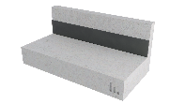 | 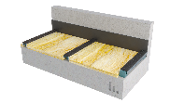 | 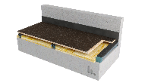 | 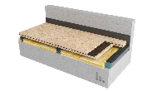 | 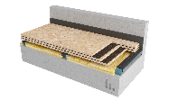 | 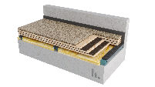
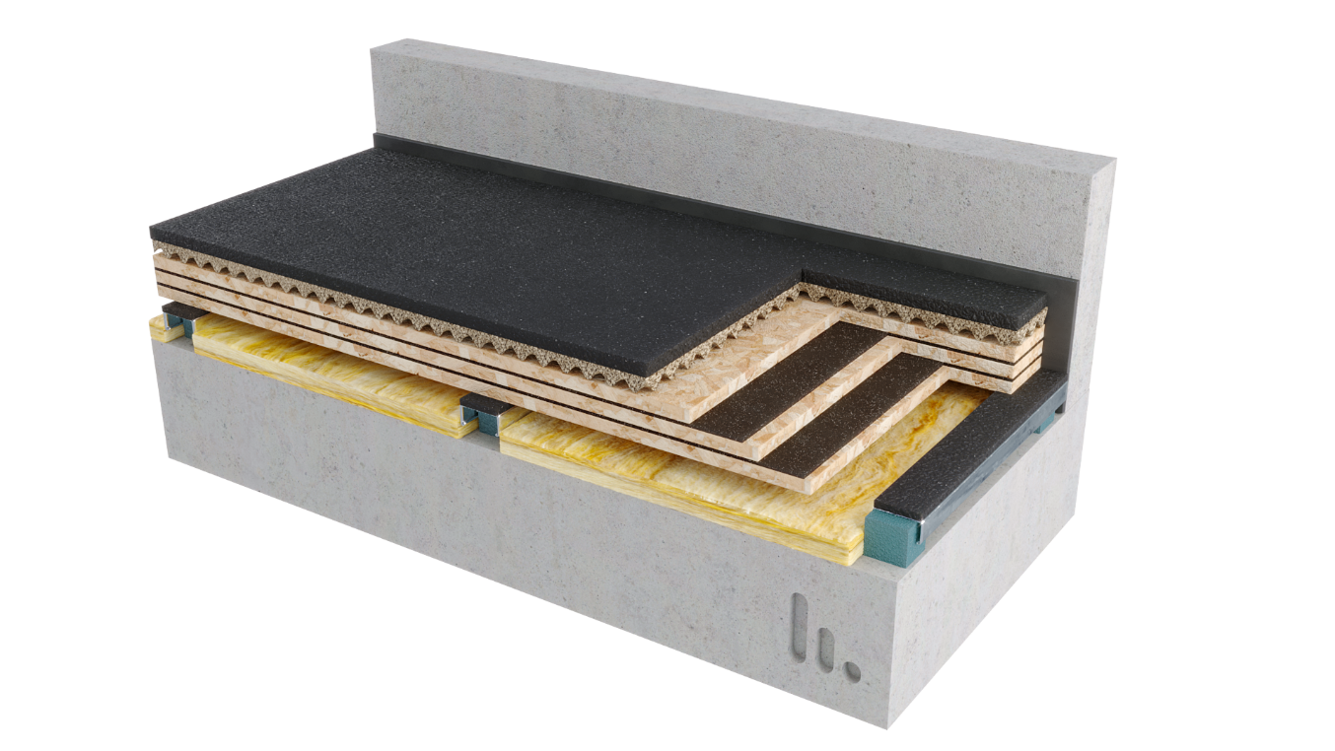

PART 1 GENERAL
  - SUMMARY

- Furnish and install all materials, labor, tools, appliances, and equipment and perform all operations necessary for installation of the isolated floating floor system, Stravigym XP, using floated panelized subfloor composites, as shown on the contract drawings and/or as described in the contract documents.

  - Related SECTIONS

Shall include but not be limited to:
- Subflooring: Section 061623

SPEC NOTE:

- Stravigym XP systems require a flat and level structural floor to be specified. (Note to Specifier: F_{F} 25 as minimum – meaning a single ¼’’ (6 mm) defect across 10-feet (3 m)).
- Caulking: This is to be coordinated with the appropriate specification or specified herein. Care should be taken to identify the proper acoustical caulking if it is in a separate specification section.

- Caulking: Section 079200

  - SYSTEM DESCRIPTION
The isolated floating floor system shall be designed, supplied, and installed as detailed in the contract drawings, and include the following components:
- Resilient Support: The resilient support shall be composed of CDM Stravitec discrete Isolation Bearing Pads installed on a CDM Stravitec dBooster® Channel.
[AND]
The resilient support shall include a dBooster® strip on top of the channel.

SPEC NOTE:
dBooster® strip may be used to decouple the board layers from the resilient support (glued to the steel channel by or following CDM Stravitec instructions), with minimal contact area and additional damping, to increase the isolation efficiency of the system and make it less dependent on the impact energy level.

Patent US 11,255,093
Patent CA 3,079,797

dBooster® is a registered trademark and the technology is patented – only CDM Stravitec or proper licensed parties are allowed to supply and install this technology.

- Isolation Bearings Pads: natural rubber isolation pads, 2’’ (50 mm) [Or 1-3/16’’ (30 mm)], designed to support the loads imposed on the floor, capable of achieving a resonant frequency lower than 6 Hz [or 10 Hz].

SPEC NOTE:
Natural Rubber Isolation Pads can achieve a resonant frequency as low as 6 Hz under varying conditions.
Spring Isolators can achieve a resonant frequency as low as 3 Hz under varying conditions.

Please contact CDM Stravitec for assistance with the design of special floating floors with low resonance frequency.
The bearings must have a creep rate < 1.5% (dec./min.) at maximum static load.
The bearings must be marked for easy identification on-site and coordination with shop drawings.

SPEC NOTE:
OPTIONAL ITEM: Sleepers or Shims may be installed under isolators to increase airspace.
[IF REQUIRED] Over-heights or Shims: rigid materials such as concrete blocks, metal or wood sleepers at thickness required by acoustician to achieve and maintain adequate airspace or flatness in system as necessary. In the event that the materials in the air cavity may be exposed to moisture or water, suitable materials should be chosen.
Shims should be, at least, 1" (25 mm) bigger than the pad, in both directions. No limits are imposed in terms of maximum height, but connection between shims and isolators should be considered to make the overall system stable if too tall.
Over-heights or shims can be installed on bottom or top of pads.
In the event shims are placed on top of the bearings, must be continuous, beam-like, with mechanical fastening between it and the channel that supports the bearings.

- Panels: The panel must suit the type of floor covering expected. Charts and related notes below can be used as guidance.

SPEC NOTE:
The bearing spacing will directly affect the performance of the overall system.

SPEC NOTE:
1. Floor covering manufacturer representative and/or installing contractor should be consulted prior to construction of isolated floor build-up for plywood deemed suitable for their finished flooring product. Confirm specific requirements for adhering and screwing layers of plywood together to create floor system on which to install finished flooring.
2. When using plywood or OSB boards ≥ 19/32’’ thick, Stravigym XP is compatible with impacts up to 1000N.m (740 lbs.ft), 800N.m (590 lbs.ft) or 600N.m (445 lbs.ft) if combined with GympactLayer-45 or GympactTile (-50 or -70), GympactLayer-20 or GympactTile-30 and no impact layer, respectively.
3. In the event of thinner boards are being used and the floor system supports heavy equipment that may be relocated due to model changes or upgrades, or direct weight drops are expected, such as used on fitness, CDM Stravitec encourages using additional layers of plywood (or OSB) to ensure more consistent distribution of the varying weights of equipment and to bring the mechanical resistance needed to coupe with the expected impact energy.

SPEC NOTE:
1. Deflection criteria: due to uniform loads, loading parallel to supports .
Valid for multi-span systems (panel across three or more supports), normal duration of load an panels 24’’ (610 mm) or wider, following APA’s Panel Design Specification.

2. Deflection criteria related with punctual loads to be checked by SEOR formwork/floating floor design.

3. Same type of table for other combinations of LL and DL or different number of panels, available upon request.

E.1 Typical thickness and type of panel based on 100 psf (5 kN/m²) LL + 25 psf (1.2kN/m²) DL, considering 3x:

Deflection criteria L/360:
Span center-to-center of bearings | Plywood Sheathing | Plywood Structural I Sheathing | Plywood Stud-I-Floor | Plywood Structural Stud-I-Floor | OSB Sheathing | OSB Structural I Sheathing | OSB Stud-I-Floor | Sanded Plywood
12''  (305 mm) | 5/16" | 5/16" | 15/32"  1/2" | 15/32"  1/2" | 5/16" | 5/16" | 15/32"  1/2" | 19/32"
16''  (406 mm) | 5/16" | 5/16" | 15/32"  1/2" | 15/32"  1/2" | 5/16" | 5/16" | 15/32"  1/2" | 19/32"
24''  (610 mm) | 19/32"  5/8" | 19/32"  5/8" | 15/32"  1/2" | 15/32"  1/2" | 19/32"  5/8" | 19/32"  5/8" | 15/32"  1/2" | 19/32"

- Damping Layer: lightweight engineered cork and rubber composite material with density ≥ 60 lb/ft3 (950 kg/m³), minimum thickness of 3/16’’ (5 mm).

- Stravifloor Perimeter Isolation Element and Penetration Interface: 1’’ (25 mm) perimeter isolation board with an apparent density of 6 lbs/cu-ft (100 kg/m³). [OPTION] Perimeter Isolation Board shall be Formaldehyde-Free.
[OR]
Alternatively, it is recommended that a 3/8’’ (10 mm) thick resilient perimeter isolation strip with a minimum density of 20 lbs/cu-ft (320 kg/m³) be used in areas where seismic loading is considered.

SPEC NOTE:
CDM Stravitec recommends one of two potential Perimeter Board:
1. Standard Item: Johns Manville Whispertone Wallboard - fine, rotary-process, borosilicate glass fibers bonded with a special thermosetting resin to produce a structurally rigid board-type insulation.
2. Formaldehyde-Free Item: Knauf Acoustical Smooth Board with ECOSE® Technology - inorganic glass fibers preformed into boards with ECOSE Technology. W/ UL Environment: GREENGUARD Certified, GREENGUARD Gold Certified, Validated to be Formaldehyde-Free and EUCEB Certified
Alternatively, use of a 3/8’’ (10 mm) resilient perimeter isolation strip with a minimum density of 20 lbs/cu-ft (320 kg/m3) in areas where seismic loading is considered is recommended.
[IF REQUIRED] Acoustic Lateral Load Bearing Isolator Pads: In order to isolate the Acoustical Floating Floor from horizontal movements due to large horizontal forces (e.g. seismic loads), Acoustic Lateral Load Bearing Isolator Pads shall be installed at the perimeter of the Acoustical Floating Floor. The Isolator Pad shall be designed to transfer the lateral forces without compromising the resonance frequency of the Acoustical Floating Floor.

SPEC NOTE:
CDM Stravitec recommends Load-bearing lateral isolation restraints to prevent lateral deflections that may occur under various load conditions as well as for projects in seismic zones.

The restrain system itself can be composed of systems like walls, curbs, or Stravifloor FAB (floor angle braces), and its design and implementation are not included in this section.

- CDM Stravitec Acoustical Batt Insulation: Provide for acoustical batt insulation with the following specifications:
      - Nominal Thickness: 3/4’’ (20 mm) | 1” (25 mm) | 1.5” (38 mm) | 2” (50 mm) | 3” (75 mm)
      - Apparent Density: equal or greater than 2 lbs/cu-ft (32 kg/m³).
      - [OPTION] Acoustical Batt Insulation shall be Formaldehyde-Free.

SPEC NOTE:
As a reference the thickness of the Acoustical Batt Insulation should be at least 75% of the cavity depth. So, for a 50 mm air cavity a 37.5 mm Acoustical Batt Insulation is recommended.

CDM Stravitec recommends one of two potential Acoustical Batt Insulation:
1. Standard Item: Rockwool Acoustical Fire Batt (AFB) - lightweight, acoustical fire batt stone wool insulation specifically designed for steel stud and wood stud interior wall and floor applications – OR EQUIVALENT. This will depend on supply chain at time of project delivery.

2. Formaldehyde-Free Item: Knauf KN Series with ECOSE® Technology - flexible to semi-rigid blankets made from inorganic glass fibers bonded with ECOSE Technology. W/ UL Environment: GREENGUARD Certified, GREENGUARD Gold Certified, Validated to be Formaldehyde-Free and EUCEB Certified

- Stravigym GympactLayer and/or GympactTile and / or GympactFloor: Check related Guide Specs.

SPEC NOTE:
OPTIONAL ITEM: Stravigym GympactLayer and/or GympactTile by CDM Stravitec – above the panels if required by acoustic consultant and compatible with expected fitness activities and expected floor covering – to extend the time of contact/impact and, therefore, reduce the peak impact force and the noise generated as well as to maximize the overall mechanical resistance of the system.

SPEC NOTE:
OPTIONAL ITEM: Stravigym GympactFloor – above the panels or impact absorption layers if required by acoustic consultant or design team and compatible with the layers bellow.

- Caulking: Perimeter of Acoustical Isolated Floating Slab to be caulked with non-hardening acoustical seal.

SPEC NOTE:
CDM Stravitec recommends the use of Tremco Acoustical Sealant or equivalent.

  - SUBMITTALS
- Shop Drawings: Submit shop drawings showing layout, profiles, product components, product data, and relevant performance information, including but not limited to:
  - Detailed product drawings, including isolator size and locations.
  - Identification of all loads for the project – Dead Loads (DL), Superimposed Dead Loads (SiDL), Live Loads (LL).
  - Calculation of static (deflection) and dynamic (resonance frequency) performance of all isolators under the following scenarios:
    - Construction Phase (CP) Load,
    - Dead Load only (DL),
    - Acoustic Design Load (ADL) – Dead Load plus Live Load with a coefficient of 25%, and
    - Serviceability Limit State (SLS) - Dead Load plus Live Load.
  - Penetrations and drain details.
  - Perimeter condition details.

- Acoustical test data from an independent laboratory showing a minimum IIC, using a panelized isolated floating floor System, on a 6” (150 mm) structural floor, of:

Solution | STC* | IIC** | HIIC*** | LIIC****
Stravigym XP with GympactLayer-20, dBooster® strip and a 2” (50 mm) Isolation Bearing Pads  (Stravigym XP-S20-M60-dB) | 65 | 72 | 91 | 82
Stravigym XP with GympactLayer-45, dBooster® strip and a 2” (50 mm) Isolation Bearing Pads  (Stravigym XP-D45-M60-dB) | 65 | 80 | 93 | 84
*Calculated according to ASTM E413-22 based on ASTM E90-09 measurements
**Calculated according to ASTM E989-21 based on ASTM E492-22 measurements
***High-Frequency Impact Insulation Class calculated according to ASTM E3222-20a
****Low-Frequency Impact Insulation Class calculated according to ASTM E3207-21

- Non-standardized weight drops acoustical test data from an independent laboratory showing Maximum A-Weighted Fast SPL (L_{AFmax}) in dBA, using panelized isolated floating floor system, on a 6’’ (150 mm) thick structural concrete floor of:

Solution | Weight Drop L_{AF,max} [dBA]
Solution | 3 kg 0.5  (6.6 lbs 20") | 7.25 kg 0.5 m  (16 lbs 20") | 7.25 kg 1 m (16 lbs 40") | 22.7 kg 0.5 m  (50 lbs 20") | 22.7 kg 1 m  (50 lbs 40")
Stravigym XP-S20-M60-dB | 52 | 53 | 60 | 56 | 66
Stravigym XP-D45-M60-dB | 44 | 47 | 53 | 49 | 61

SPEC NOTE:
Item above relative to Acoustical test data references a requirement for “tests conducted within the last 10 years”. It should be noted that this is different from the test report as it is common practise for laboratories to re-issue reports with new test report dates for testing that occurred outside of a 10-year test date.
CDM Stravitec provides various acoustic tests for different floor setups on www.stravi-dB.com. In addition to the test reports, editable .csv files with data and typical cross-sections are also available.


  - QUALITY ASSURANCE

- The Stravigym XP system shall be installed by an experienced installer specialized in the installation of similar work to that of this project, either under direction from or by authorization of CDM Stravitec.
- The Stravigym XP manufacturer shall have a minimum of 10 similar projects within the past 5 years and be capable of providing field service representation during installation.
- The system shall be designed and fabricated by CDM Stravitec and subjected to CDM Stravitec Quality Assurance program.

  - DELIVERY, STORAGE, AND HANDLING

- Ordering: Comply with the manufacturer's ordering process and lead time requirements to avoid project delays.
- Delivery: Deliver materials in manufacturer's original, unopened, undamaged containers with identification labels intact.
- Storage and Protection: Materials shall be stored in a conditioned space recommended by the manufacturer and protected from external weather conditions.

  - PROJECT CONDITIONS

    - If site conditions are unsatisfactory or raise questions about the installation and/or performance of the floating floor, the work shall not proceed until the condition has been corrected in a manner acceptable to meet the Isolated Floating Floor System Manufacturer’s guidelines.

  - WARRANTY

- Manufacturer’s Warranty: Submit, for the owner’s acceptance, the manufacturer’s standard warranty document executed by an authorized company official. The manufacturer’s warranty is in addition to and not a limitation of other rights the Owner may have under Contract Documents.

PART 2 PRODUCTS
2.01 MATERIALS
- Manufacturer:
CDM Stravitec, Inc.
Address: 342 N. Queen St., Warehouse D, Lancaster, PA 17603
Phone: 888-454-6236
Email: info-us@cdm-stravitec.com
Web: www.cdm-stravitec.com

- Products:
  - Stravigym XP and associated accessories as described in Part 1 of this Section.

2.02 SUBSTITUTION OF MATERIALS
SPEC NOTE:
Choose one of the following statements as desired by the design team.

- Substitute materials shall meet or exceed the “quality and performance” of the products which are listed in these Specifications. Submit samples and test reports by an independent laboratory for consideration on this project.

[OR]

A. No substitutions are permitted.

PART 3 EXECUTION
3.01 INSTALLATION

- The installation of the Isolated Floating Floor System specified herein shall be in accordance with procedures submitted by the System manufacturer and approved by the Design Team (architect, structural and acoustical).
- The base structural slab receiving the Isolated Floating Floor System shall be flat, smooth structural surface, cleared of debris and broom swept; any required waterproofing properly installed. The flatness of the supporting floor should be a maximum of 1/4” (6 mm) over 10’ (3 m) – F_{F} 25 (according to ASTM E1155-14 and American concrete Institute publication ACI 302) - to ensure a successful installation.
If the supporting floor is not completely flat and level then use a fast-drying, self-levelling compound across the whole floor to achieve required flatness criteria.
- All walls, columns, and service penetrations through the floating floor should be isolated using strips of perimeter isolation or similar material as required to meet the geometry on site. The height of this isolation should be at a minimum equal to the thickness of the Isolated Floating Floor System.
Do not use any fasteners through the perimeter isolation material.
- Isolated channels (with or without dBooster® strips) must be installed per the shop drawings. Isolated channels are to be installed loose laid without the use of mechanical fixings or adhesive. If more than one type of channel (different in type or number of bearings) is being used, carefully check the layout of each isolated channel type correlates with the drawings – this can be done by matching the color and number of the pad to the color and number indicated on the drawing.
- Absorption layer should be installed between channels (neve under the channels), being loose laid without mechanical or adhesive fixing.
- Loose lay the first panel perpendicular to the steel channels. Take care to ensure that all board joints are located at the centre of a steel channel so that the joint is supported.
If dBooster® technology is being used, the panel shouldn’t be fixed to the steel channels.
If dBooster® technology isn’t being used, mechanically fix the boards to the steel channels using a screw that is short enough to not make contact with the supporting floor underneath.
- Loose lay the Damping Layer sheet between board layer without any overlaps and ensure the entire floor is covered. The Damping Layer joints should be staggered so they are not located in the same place as the board joints.
- The second board layer should be installed on top of the first layer at a 90º relation, staggering joints a minimum equal to the bearings spacing, top to bottom.
- The second layer of Damping Layer must be installed following the same procedure than the firs.
- The third board layer should be installed on top of the second layer at a 90º relation, staggering joints a minimum equal to the bearings spacing, top to bottom.
The board and Damping layer layers should be mechanically fixed together using screws with limited length to avoid contact with the subfloor after bearing deflection and consequent acoustical bridges or pad punctuation of the pads (as well as to avoid having the board fixed to the steel channel when dBooster® technology is being considered). If mechanical fixings are specified to connect the panel layers, consult CDM Stravitec for the appropriate fixing type, length, and installation pattern.
Spacing of the top board layer, edge to edge, should be determined by the finish flooring manufacturer. Example: Hardwood floor companies often recommend a 1/8” (3.2 mm) space between plywood sheets (top layer).

SPEC NOTE:
OPTIONAL ITEM: Stravigym GympactLayer and/or GympactTile to be specified by acoustic consultant..

- Stravigym GympactLayer or Stravigym GympactTile should be installed by loose laying it on the second board layer (with T&G connectors to connect GympacTile solution and enhanced stability).
If the Stravigym GympactLayer is composed of more than one layer (as is the case for Stravigym GympactLayer-45) stagger the sheets to ensure the joints of the two layers are not located in the same place. The profiled sheet is always the first one to be installed – with the profile facing down onto the board layer.
For enhanced stability the Stravigym GympactLayer can be permanently fixed to the board by using either a double-sided adhesive tape or a two-component polyurethane adhesive. Both methods can also be used to glue the two layers of Stravigym GympactLayer together, but never the dimple component to the board layers.

- Trim any excess perimeter isolation material to the finished floor height and seal around the perimeter with a suitable elastic caulk.

SPEC NOTE:
OPTIONAL ITEM: Stravigym GympactFloor to be specified by acoustic consultant or design team.

- The final floor finish (by CDM Stravitec – Stravigym GympactFloor (-P)), should be installed using the manufacturers installation instructions, following them installation instructions. Ensure that the final floor finish is not rigidly connected to the surrounding walls.
- All sound isolation materials and building components supported by isolation materials are to be completely free from rigid contact with any part of the building structure.

  - PROTECTION
    - Foot traffic during installation shall be kept to a minimum. In the event the floor system will be required to handle loads imparted by construction lifts, scaffolding, temporary mechanical equipment loads, and temporary construction sequencing, CDM Stravitec encourages using spreader plates to protect the isolation system.
    - Products shall be protected from damage during construction.
    - Any vented or open perimeters shall remain free and clear of debris.
    - The operation of heavy equipment and machinery on the floating floor shall be verified with the manufacturer before use.

END OF SECTION

