Recommended Specifications for
Stravifloor Jackup-R

Section 13 48 00 Sound Control
This document is for specification writers' reference in the drafting process. CDM Stravitec will not be held responsible for the use or unauthorized modification of any information contained herein.

Specification notes are identified in the document as follows “SPEC NOTE” – these notes must be removed from final documents. Where multiple options may be available, these are identified in the corresponding spec note.

Text highlighted in yellow indicates text that should be coordinated with the entire spec book or represent sections that are options not found on every installation.

This document specification has been specifically written for the Stravifloor Jackup-R system. Below is a schematic indication of the construction process from start to end, as described in this specification.
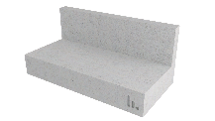 | 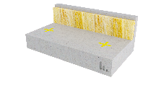 | 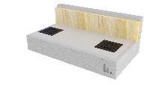 | 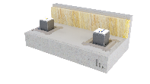 | 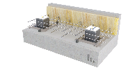 | 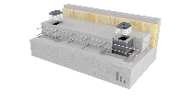
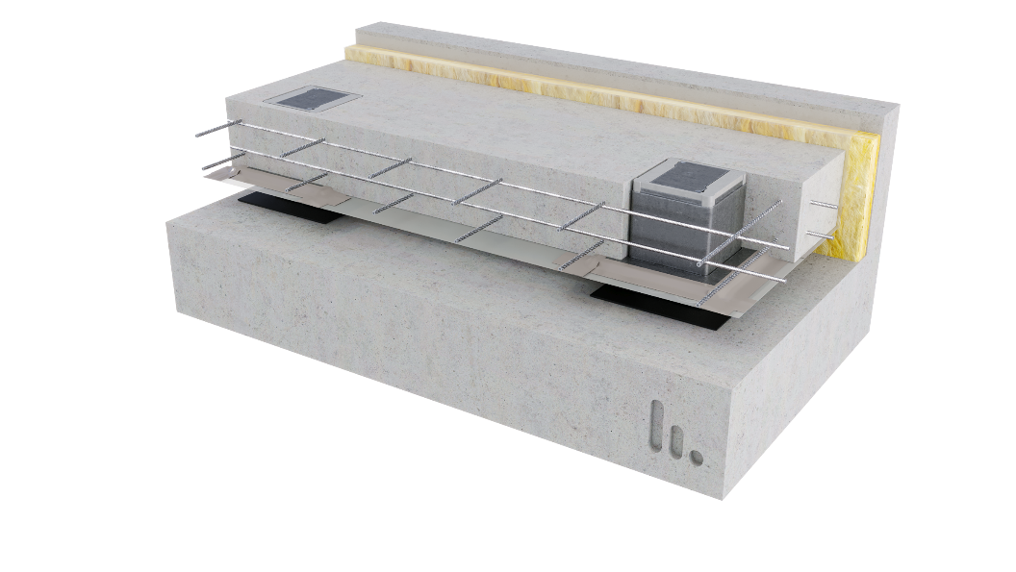

PART 1 GENERAL
  - SUMMARY

- Furnish and install all materials, labor, tools, appliances, and equipment and perform all operations necessary for installation of the isolated floating floor system, Stravifloor Jackup-R, as shown on the contract drawings and/or as described in the contract documents.

  - Related SECTIONS
Shall include but not be limited to:
- Concrete and reinforcing: Section 3

SPEC NOTE:
- Stravifloor Jackup-R systems require a flat and level structural floor to be specified. All Stravifloor Jackup-R mounts are a fixed height, so the contour of the structural floor controls the flatness and levelness of the finished floated slab. (Note to Specifier: F_{F}25 as minimum – meaning a single ¼’’ (6 mm) defect across 10-feet (3 m)).
- Caulking: This is to be coordinated with the appropriate specification or specified herein. Care should be taken to identify the proper acoustical caulking if it is in a separate specification section.

- Metal pipe and conduit sleeves (Plumbing and Electrical): Section 22 & Section 26
- Caulking: Section 079200

  - SYSTEM DESCRIPTION
The isolated floating floor system shall be designed, supplied, and installed as detailed in the contract drawings, and include the following components:
- Stravifloor Jackup-R Isolated Floating Floor System: which is composed of: a square shaped steel housing, an adjustment plate, loading plate and lifting bolt the height of which is adjusted to project requirements. The system is complete with a Spring or Elastomeric Isolator, capable of achieving a resonant frequency as low as 3 Hz or 6 Hz respectively. Minimum height of Jackup-R box is 4” (100 mm).
- Construction Grade Polyethylene Sheeting: Construction grade Polyethylene sheeting with a nominal thickness larger or equal than 6 mils.
- Stravifloor Perimeter Isolation Element: 1’’ (25 mm) perimeter isolation board with an apparent density of 6 lbs/cu-ft (100 kg/m³). Alternatively use of a 3/8’’ (10 mm) thick resilient perimeter isolation strip with a minimum density of 20 lbs/cu-ft (320 kg/m³) in areas where seismic loading is considered is recommended.

SPEC NOTE:
OPTIONAL ITEM: Batt insulation to be specified by the acoustic consultant.

- Stravifloor Acoustical Batt Insulation: Provide for acoustical batt insulation with the following specifications:
      - Nominal Thickness: 1” (25 mm) | 1.5” (38 mm) | 2” (50 mm) | 3” (75 mm)
      - Apparent Density: greater than 2 lbs/cu-ft (32 kg/m³).

SPEC NOTE:
Load bearing lateral isolation restraints, as well as for projects in seismic zones which require edge restraint.

- Stravifloor FAB: Provide acoustical load bearing isolation restrains as required per project documents and/or drawings.

SPEC NOTE:
Provide information for caulking if required

- Caulking: Perimeter of Acoustical Isolated Floating Slab to be caulked with non-hardening acoustical seal.

- Concrete for Isolated Floating Floor System: Provide normal weight (UNO by design team) with concrete with a minimum compressive strength of 4000 psi (28 MPa) at 28 days. Slab should be properly reinforced to sustain self-weight loads, imposed and live loads. Slab reinforcement and curing per structural design, respecting the code minimums specified and SEOR floating floor design.

SPEC NOTE:
Minimum 4000 psi (28 MPa), standard weight concrete. The slab should be properly reinforced and cured per structural design, respecting the code minimums specified and SEOR floating floor design.

CDM Stravitec recommends a minimum rebar reinforcement as follows:
• For the 4” slabs (100 mm): #4@10”, One mesh, cover ½”.
• For the 6” slabs (150 mm): #3@10”, Top & Bottom meshes, cover ¾”.
• For the 8” slabs (200 mm): #3@10”, Top & Bottom meshes, cover ¾”.

With a minimum splicing of 50db i.e., 500 mm for the #3s and 600 mm for the #4s.
Lightweight concrete can also be considered however test data may not be available to justify performance.

  - SUBMITTALS
- Shop Drawings: Submit shop drawings showing layout, profiles, product components, product data, and relevant performance information, including but not limited to:
  - Detailed product drawings, including isolator size and locations.
  - Identification of all loads for the project – Dead Loads (DL), Superimposed Dead Loads (SiDL), Live Loads (LL).
  - Calculation of static (deflection) and dynamic (resonance frequency) performance of all isolators under the following scenarios:
    - Construction Phase (CP) Load,
    - Dead Load only (DL),
    - Acoustic Design Load (ADL) – Dead Load plus Live Load with a coefficient of 25%, and
    - Serviceability Limit State (SLS) - Dead Load plus Live Load.
  - Penetrations and drain details.
  - Perimeter condition details.
- Acoustical test data from an independent laboratory showing a minimum STC of 61 and IIC of 62 using a 4” (100mm) Isolated Floating Floor System, on a 6” (150 mm) structural floor, with a 2” (50mm) air gap.

SPEC NOTE:
Item above relative to Acoustical test data references a requirement for “tests conducted within the last 10 years”. It should be noted that this is different from the test report as it is common practise for laboratories to re-issue reports with new test report date.
Stravi-dB:
CDM Stravitec provides various acoustic tests for different floor setups on www.stravi-dB.com. In addition to the test reports, editable .csv files with data and typical cross-sections are also available.


  - QUALITY ASSURANCE
The Stravifloor Jackup-R system shall be installed by an experienced installer specialized in the installation of similar work to that of this project.
- The jack-up manufacturer shall have a minimum of 10 similar projects within the past 5 years and be capable of providing field service representation during installation.
- The system shall be designed and fabricated by CDM Stravitec and subjected to CDM Stravitec Quality Assurance program.

  - DELIVERY, STORAGE, AND HANDLING
- Ordering: Comply with the manufacturer's ordering process and lead time requirements to avoid project delays.
- Delivery: Deliver materials in manufacturer's original, unopened, undamaged containers with identification labels intact.
- Storage and Protection: Materials shall be stored in a conditioned space recommended by the manufacturer and protected from external weather conditions.

  - PROJECT CONDITIONS
    - If site conditions are unsatisfactory or raise questions about the installation and/or performance of the floating floor, the work shall not proceed until the condition has been corrected in a manner acceptable to meet the Isolated Floating Floor System Manufacturer’s guidelines.

  - WARRANTY
- Manufacturer’s Warranty: Submit, for the owner’s acceptance, the manufacturer’s standard warranty document executed by an authorized company official. The manufacturer’s warranty is in addition to and not a limitation of other rights the Owner may have under Contract Documents.

PART 2 PRODUCTS
2.01 MATERIALS
- Manufacturer:

CDM Stravitec, Inc.
Address: 342 N. Queen St., Warehouse D, Lancaster, PA 17603
Phone: 888-454-6236
Email: info-us@cdm-stravitec.com
Web: www.cdm-stravitec.com

- Products:
- Stravifloor Jackup-R and associated accessories as described in Part 1 of this Section.

2.02 SUBSTITUTION OF MATERIALS
SPEC NOTE:
Choose one of the following statements as desired by the design team.

- Substitute materials shall meet or exceed the “quality and performance” of the products which are listed in these Specifications. Submit samples and test reports by an independent laboratory for consideration on this project.

[OR]

A. No substitutions are permitted.

PART 3 EXECUTION
3.01 INSTALLATION
The installation of the Isolated Floating Floor System specified herein shall be in accordance with procedures submitted by the System manufacturer and approved by the Design Team (architect, structural and acoustical).
- The base structural slab receiving the Isolated Floating Floor System shall be flat, smooth structural surface, cleared of debris and broom swept; any required waterproofing properly installed.

SPEC NOTE:
The flatness of the supporting floor should be a maximum of 1/4” (6 mm) over 10-feet (3 m) – F_{F}25 (according to ASTM E1155-14 and American concrete Institute publication ACI 302) - to ensure a successful installation.
a. If the supporting floor is not completely flat and level the use of a fast-drying, self-levelling compound across the whole floor to achieve required flatness criteria.
b. The contour/levelness of the structural slab determines the same for the floating slab.
- Using the installation plans supplied, mark out the location of the center of each box across the whole floor.
- All walls, columns, and service penetrations through the floating floor should be isolated using strips of perimeter isolation or similar material as required to meet the geometry on site. The height of this isolation should be at a minimum equal to the thickness of the Isolated Floating Floor System.
- [OPTION] When using an absorption layer in the Isolated Floating Slab System cavity (between floating slab and structural slab), provide at the locations where the boxes will be installed over-height to raise the boxes from structural slab (using fibercement board plate or other approved material) with same thickness as absorption layer.
- Prior to the placement of isolator assemblies, a protective layer of construction grade polyethylene sheeting shall be installed over the whole floor and continued up the wall to cover the perimeter isolation strip.
  - The protection layer shall consist of one layer of polyethylene sheeting overlapped and taped at all seams and at all connections where the vertical edge of the isolated slab contacts the building.
  - All overlaps should be a minimum of 4’’ (100 mm) and then sealed using a 2’’ (50 mm) (minimum) wide construction grade self-adhesive tape.
  - Ensure the protection layer is fitted neatly into the corner areas of the floor to avoid any pocketing which could result in a reduction of slab thickness in these areas.
- All isolator assemblies shall be placed on the marks, per floor submittal, ensuring the correct positioning of the pad to make sure there are no gaps where leakage could occur.
  - Verify that the EPDM bottom plate, and Jackup-R Boxes are placed at each marked location prior to the concrete pour. Ensure that that there are no gaps under the base flange of the housing which could allow entry of concrete slurry.
  - Verify that the distance between the center-to-center distance between boxes and the center to the edge of the floor on perimeter boxes are stated in the shop drawings.
- Install reinforcing bars as required and identified by structural engineer.
- Once you have ensured that all boxes are adequately closed and sealed, the concrete can be poured to the required height.
- Once the concrete has cured to the required strength remove the stickers and open the top lid by removing the two screws holding it in place.
- Insert the elastomeric or spring bearings as indicated on the plan. Position the bearings on the bottom plate.
- Jack-up the floor as defined in the installation manual from manufacturer and identified in the shop drawings.
- Trim the perimeter isolation to the finished floor height. Seal the perimeter with a suitable elastic caulk. The floor is now ready for use.

  - PROTECTION
    - Foot traffic during installation shall be kept to a minimum.
    - Products shall be protected from damage during construction.
    - Any vented or open perimeters shall remain free and clear of debris.
    - The operation of heavy equipment and machinery on the floating floor shall be verified with the manufacturer before use.

END OF SECTION

