Recommended Specifications for
Stravigym GympactTile

Section 13 48 00 Sound Control
This document is for specification writers' reference in the drafting process. CDM Stravitec will not be held responsible for the use or unauthorized modification of any information contained herein.
Specification notes are identified in the document as follows “SPEC NOTE” – these notes must be removed from final documents. Where multiple options may be available, these are identified in the corresponding spec note.

Text highlighted in yellow indicates text that should be coordinated with the entire spec book or represents sections that are options not found on every installation.

This document specification has been specifically written for the Stravigym GympactTile system. Below is a schematic indication of the construction process from start to end as described in this specification.

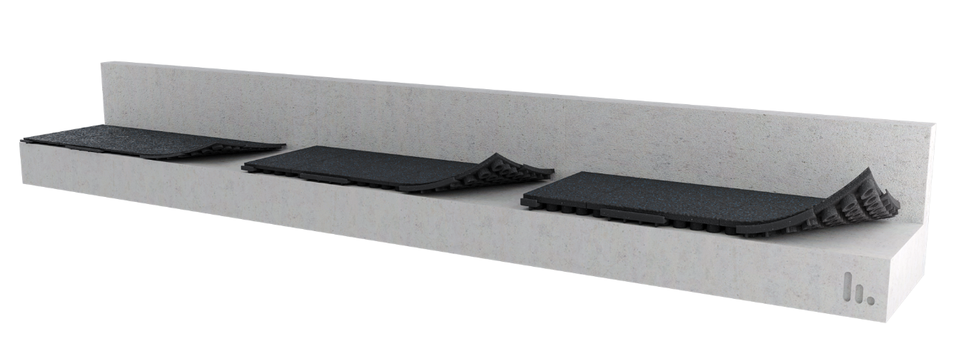

PART 1 GENERAL
  - SUMMARY

- Furnish and install all materials, labor, tools, appliances, and equipment and perform all operations necessary for installation of the isolated floating floor system, Stravigym GympactTile, as shown on the contract drawings and/or as described in the contract documents.

  - Related SECTIONS

Shall include but not be limited to:
- Subflooring: Section 061623

SPEC NOTE:
1) Stravigym GympactLayer solution require a flat and level floor to be specified. (Note to Specifier: FF 25 as minimum – meaning a single ¼’’ (6 mm) defect across 10-feet (3 m)).

  - SYSTEM DESCRIPTION
The isolated floating floor system shall be designed, supplied, and installed as detailed in the contract drawings, and include the following components:
- Tiles: resilient interlocking acoustic fitness flooring tiles made of compression-molded, recycled rubber and binding agents.
Each tile with U-shaped male and female configuration on all 4 sides to lock tiles to adjacent tiles and chamfered top edges.
Each tile with black top wear layer obtained from compression molded to achieve optimal density and durability and made of a combination of elongated SBR rubber and granulated crumb rubber; and hollow core stanchion patten.
Each tile with 24.25” (615.95 mm) x 24.25” (615.95 mm) [± 1/8” (3mm)] and 19.40 pounds (8.75 kg), 25.00 pounds (11.34 kg) and 29 pounds (13.15 kg) if 1.25’’ (30 mm), 2’’ (50 mm) or 2.75’’ (70 mm) thick, respectively.

Other mechanical and physical characteristics, according:
Test Description | Standard | Results
Freeze/Thaw | ASTM C67 | No deterioration
Rubber Deterioration/Air Oven | ASTM D573 | No deterioration
Slip Resistance | ASTM D303 | Dry 102/Wet 62
Slip Resistance | ASTM D2047 | Dry 0.81/Wet 0.82
Compression Deflection | ASTM D1667 | 29.5 PSI to 25% Compression
Compression Set | ASTM D395 | 4.37% Permanent Set
Tensile Strength | ASTM D412 | 107 psi (0.7 MPa)
Elongation at Break | ASTM D412 | 165%
Tear Strength | ASTM D624 | 33.1 Lbs/Inch (228 kN/m²)
Wear Surface Density (Durability) | - | >60 lbs/Cu Ft (960 kg/m³)

SPEC NOTE:
OPTIONAL ITEM: Transitional ramps and conners if required by an acoustic consultant or design team.

- Transitional ramps: prefabricated outside and inside conner ramps, and ramps made of the same material as surfacing tiles, same color and thickness. Ramps should be ADA-compliant.

  - SUBMITTALS
- Product Data: Manufacturer's data sheets on each product to be used, including:
      - Preparation of instructions and recommendations.
      - Storage and handling requirements and recommendations.
      - Installation methods.
- Selection and verification Samples.
- Installation instructions, including shop drawings showing layout.
- Acoustical test data from an independent laboratory showing a minimum IIC, using panelised isolated floating floor System, on a 6” (150 mm) structural floor, of:

Solution | IIC | ∆IIC | STC
Stravigym GympactTile-30 | 56 | 26 | 55
Stravigym GympactTile-50 | 62 | 27 | 54
Stravigym GympactTile-70 | 64 | 28 | 57

- Non-standardized weight drop acoutical test data from an independent laboratory showing minimum Peak A-Weighted SPL - dBA ref 20 μPa, using panelized isolated floating floor system, om a 8’’ (200 mm) structural floor (including a 6 mm (0.236 in.) steel plate with a weight of 18.37 kg (40.5 lbs) to protect the concrete slab from the weight drop), of:

Solution | Weight Drop (Peak A-Weighted SPL - dBA ref 20 μPa)
Solution | 25 lbs 36" | 25 lbs 60" | 55 lbs 36" | 55 lbs 60"
Stravigym GympactTile-30 | 79 | 86 | 87 | 92
Stravigym GympactTile-50 | 68 | 73 | 74 | 79
Stravigym GympactTile-70 | 69 | 73 | 71 | 75

  - QUALITY ASSURANCE

- The Stravigym GympactTile system shall be installed by an experienced installer specialized in the installation of similar work to that of this project, either under direction from or by authorization of CDM Stravitec.
- The Stravigym GympactTile manufacturer shall have a minimum of 10 similar projects within the past 5 years and be capable of providing field service representation during installation.
- The system shall be designed and fabricated by CDM Stravitec and subjected to CDM Stravitec Quality Assurance program.

  - DELIVERY, STORAGE, AND HANDLING

- Ordering: Comply with the manufacturer's ordering process and lead time requirements to avoid project delays.
- Delivery: Deliver materials in manufacturer's original, unopened, undamaged containers with identification labels intact.
- Storage and Protection: Materials shall be stored in a conditioned space recommended by the manufacturer and protected from external weather conditions.

  - PROJECT CONDITIONS

    - If site conditions are unsatisfactory or raise questions about the installation and/or performance of the floating floor, the work shall not proceed until the condition has been corrected in a manner acceptable to meet the Isolated Floating Floor System Manufacturer’s guidelines.

  - WARRANTY

- Manufacturer’s Warranty: Submit, for the owner’s acceptance, the manufacturer’s standard warranty document executed by an authorized company official. The manufacturer’s warranty is in addition to and not a limitation of other rights the Owner may have under Contract Documents.

PART 2 PRODUCTS
2.01 MATERIALS
- Manufacturer:
CDM Stravitec, Inc.
Address: 342 N. Queen St., Warehouse D, Lancaster, PA 17603
Phone: 888-454-6236
Email: info-us@cdm-stravitec.com
Web: www.cdm-stravitec.com

- Products:
  - Stravigym GympactTile and associated accessories as described in Part 1 of this Section.

2.02 SUBSTITUTION OF MATERIALS

SPEC NOTE:
Choose one of the following statements as desired by the design team.

- Substitute materials shall meet or exceed the “quality and performance” of the products which are listed in these Specifications. Submit samples and test reports by an independent laboratory for consideration on this project.

[OR]

A. No substitutions are permitted.

PART 3 EXECUTION
3.01 INSTALLATION

- The installation of the Isolated Floating Floor System specified herein shall be in accordance with procedures submitted by the System manufacturer and approved by the Design Team (architect, structural and acoustical).
- Stravigym GympactTile athletic flooring must be installed correctly in order to maintain CDM Stravitec’ manufacturer’s warranty. It is imperative that all tiles be installed under compression to create a tight seam between the tiles. Failure to install the Stravigym GympactTile system under compression to the dimensions outlined in this manual will void the system’s warranty. By carefully following the instructions below, you will be able to achieve the required compression during installation.
- The subfloor receiving GympactTile solution shall be flat, smooth structural surface, cleared of debris and broom swept; any required waterproofing properly installed. The flatness of the supporting floor should be a maximum of 1/4” (6 mm) over 10’ (3 m) – FF 25 (according to ASTM E1155-14 and American concrete Institute publication ACI 302) - to ensure a successful installation.
If the supporting floor is not completely flat and level then use a fast-drying, self-levelling compound across the whole floor to achieve required flatness criteria.
- Locate, measure and chalk line the vertical and horizontal center lines in the room. Center lines should be shifted based on the best visual effect on the perimeter cuts. When possible, perimeter cuts should be a minimum of 10’’ (254 mm) in width.
- From the center point in the area, strike chalk lines in 24”(609.6 mm) increments (for Stravigym GympactTile-70) or 24.125” (612.775 mm) (for Stravigym GympactTile-50) in both directions so that a grid pattern is created across the entire area.

SPEC NOTE:
Choose one of the following statements as desired by the design team.

- If transitional ramps are being used on one or more sides, they must be permanently secured to the floor to provide a fixed point of compression for the field tiles. Prior to the installation of field tiles, locate the final position of the transitional ramps and fix them in place with the supplied adhesive. Adhesive must be fully cured before compression can be applied to the transitional edge.
- To properly compress all of the field tiles, the perimeter of the room must be cut in and placed first. At each seam location along the chalk line around the perimeter of the room, measure the distance from the line to the wall and add 1/16’’ (15 mm) to this measurement and write that dimension on the floor. Continue this process at every seam around the perimeter of the room (every 24” (610 mm)). Transfer these measurements onto the tile. Cut tiles with a sharp, heavy duty utility knife and metal straight edge on the line but with a back-cut or undercut of approximately 5 degrees. Install the cut tiles all the way around the perimeter. Start at the corners and work around the room. Perimeter tiles should be installed in 6 tile increments leaving a one-tile space between each 6-tile row. This is done to make compression easier by balancing the compressive forces throughout the floor.
Compress the final perimeter tiles into the remaining voids.
- Install the field tiles running in one direction only across the room. Install every other row of tiles only. Begin at the perimeter cuts at each end of the room. Tile rows should be installed in approximately 6-tile increments leaving a one-tile space between each 6-tile row. The number of tiles between spaces may need to be adjusted based on the room dimensions.
- Begin installing the tiles in the empty space located between the 6 tile increments. These tiles represent the compression tiles and will need to be compressed into a space smaller than the tile. The locking mechanism on each edge of the tile should be engaged with the adjacent tile forcing the tile to buckle upwards. Once the links are engaged, force the tile flat by applying downward pressure onto the tile. This is normally done using a kicking motion or a sledgehammer.
- Once every other row of tile has been installed and com-pressed into place, begin installing every other row of tile in the opposite direction, using the same process as described before.
- At this point in the installation your tile layout should look like the drawing. The remaining spaces in the floor are smaller than the tiles that will be placed and therefore each tile must be forced into place. The process of forcing each remaining tile into place will compress all of the remaining tiles in opposite directions.

  - PROTECTION
    - Foot traffic during installation shall be kept to a minimum.
    - Products shall be protected from damage during construction.
    - Any vented or open perimeters shall remain free and clear of debris.
    - The operation of heavy equipment and machinery on the floating floor shall be verified with the manufacturer before use.

END OF SECTION

